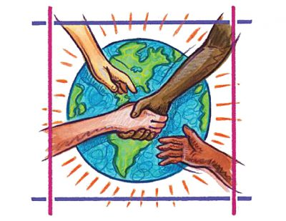
What can we do to save the planet?

Group:
Names:

- Think about the problems of the world and what we can do make the world a better place.
Give examples, write down your ideas.
- Consider your daily routine, choices and values.

Work within your group.

- Talk about the possibilities. Share your knowledge, compare and discuss it.
- Take notes if you need to. One of you or each of you – as you like it.

What can we do? | Why? (aim)
example: sort and recycle your rubbish | example: to reduce rubbish, to re-use material

