Title of Lesson | Time Required | Age Range | Resources required
Migration Journeys - Why the Journey? | 2 hours | 10 - 13 | Paper, pens, etc, as described in methodology (in Main Activity, below)

Lesson Objective | Knowledge and Understanding (Global Theme covered) | Global Skills covered | Global Values and Attitudes covered
Understand that unfair distribution of resources impacts upon productivity | Social justice and equity | Cooperation & conflict resolution | Commitment to social justice and equity

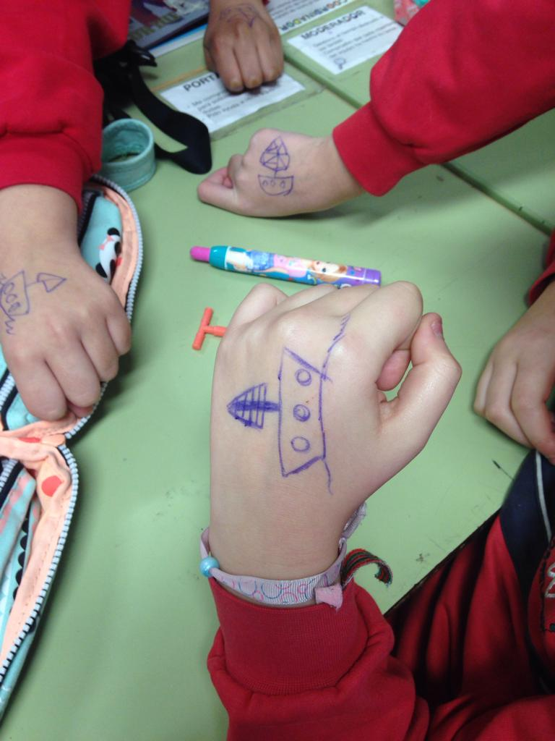
Introduction
This activity is part of a series looking at the migratory journey. These lessons focus on the migratory journey, - the journey that a person makes from the place of origin until arriving at the destination. The overall aim is to support students to analyze the differences between places and the causes underpinning migratory journeys.
This lesson introduces the theme using a simulation game. Students need to cooperate in order to build paper boats with unequal provision of resources and labour. The aim is to stimulate discussion around fairness, inequality and problem solving, raising awareness of global issues which impact on people's lives and migratory flows.
Teachers can adapt the timing and organisation of the game depending on their knowledge of children in their class. Be aware that such games can provoke an emotional reaction, so careful classroom management and debriefing are essential.

Main Activity
Methodology:
Divide the class into 5 groups and challenge each group to make a paper boat.
TOP TIP: Do not specify too much the dynamics to the participants.
- Each group must make a paper boat with the materials that they have.
- Paper ships must be manufactured and teacher will accept those that are badly made
- No one can use other materials that those supplied for the task.
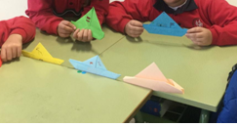
Materials:
(Group size and distribution will need to be adjusted to accommodate the number of students)
Group 1: It will be formed by three people, will have many coloured sheets of paper and pens.
Group 2: Will consist of four people, a white sheets of paper for each group member and 2 pens
Group 3: It will be formed by five people, they will have 4 coloured sheets of paper (without pen).
Group 4: It will be formed by six people, they will have 4 white sheets of paper (without pen).
Group 5: It will be formed by the rest of the group, they will have a single pen.
Watch this simple video to see how to make a very simple boat/hat (similar to those shown in the photographs: https://www.youtube.com/watch?v=1TekA1Q8pc0

Plenary
How did this activity make you feel? Could you build your boats? Why have you not been able to build them? How did those who could build boats feel? What advantages did they have? How do you consider this deal? Did you find any way to overcome the challenge to make your boat?
Do you think this has something to do with the distribution of wealth in the world? What have you learned from this?
This activity could be used as a stimulus for a Philosophy for Children session.
Help the children to identify the key themes explored - Fairness/ inequality/wealth/poverty etc and encourage them to generate their own big questions around the theme.
Air the questions and vote for the question the group would like to discuss in circle time.
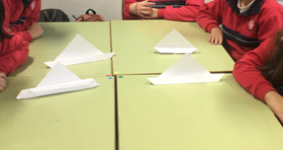
What were the Outcomes?
The children were enabled to explore inequality within the classroom setting and relate this to the distribution of world resources. It provided an opportunity to reflect upon their own feelings and reactions to an unfair situation.
Cooperation, negotiation and communication skills were enhanced.

