Title of Lesson | Time Required | Age Range | Resources required
What is a Journey? | 6 x 20 minute sessions | 6 & under | Book - The Raft – by Lucia Salemi

Lesson Objective | Knowledge and Understanding (Global Theme covered) | Global Skills covered | Global Values and Attitudes covered
To explore feelings and needs through story and role play | Social justice and equity | Empathy  Self awareness and Reflection  ​Communication | Value diversity  ​Commitment to participation and inclusion

Introduction
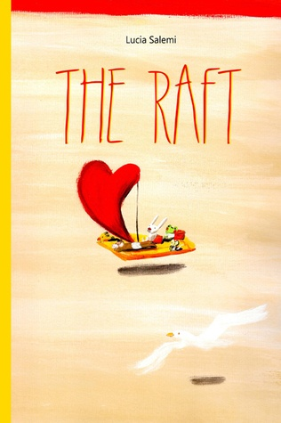
Use key question "What is a journey?" to establish children's understanding of the vocabulary. Name and identify different vehicles from familiar to unfamiliar forms of transport. Introduce the idea of a raft: What is it? How does it travel? How far can it travel? What are its advantages and disadvantages?

Main Activity
Adapt and retell the story "The Raft" using actions and mime to introduce the characters of mouse, rabbit, toad, monkey and chick and the contents of their suitcases through the telling of the story:
Mouse - ray of sunshine to overcome fear of darkness
Chick - rainbow to overcome sadness
Toad - Cloud of rain to overcome thirst
Monkey - blanket to overcome cold
Rabbit - heart to overcome challenges
Use role play for children to explore the fears and emotions embodied in the story (fear, thirst, hunger, cold, hope) through discussion of the characters and how they help each other. Relate to school and life.
Consolidate learning by asking children to paint the characters, with their symbols. Revisit the story in sections to reinforce the vocabulary, message and story of each character during circle time.
Display art work as a reference point for future discussions on values, cooperation, feelings, friendship to build classroom ethos.
Extend learning across the curriculum - for example, make rafts out of recycled and natural materials to explore floating and sinking in water play/construction tasks.

Plenary
Ask the children what the characters would have found when they reached a new place to live. What new place would the animals like to find?
How would we welcome a mouse, a chick, a rabbit etc that have come from afar. What would it be like to speak in another language, eat different foods? Could the contents of their suitcases help the new friends they will meet in the future?
Share the idea that everyone has an "invisible suitcase" which they can use to help themselves and others. Collect ideas of what the children carry with them - kindness, helpfulness, bravery, friendliness, smiles etc that they can use at any time.

What were the Outcomes?
This activity was trialled in short sessions over a period of three weeks and it was successful at improving communication and empathy between children from different backgrounds and cultures. Quieter children participated as they were not afraid of giving a "wrong" answer. Children were more able to discuss their feelings and ask questions about different countries and cultures. They referred to the story and the characters in conversation long after the activities had been completed.

