Title of Lesson | Time Required | Age Range | Resources required
Playing with Empathy | 2-4 hours | 7+ | Koi and the Kola Nuts by Verna Aaardema

Lesson Objective | Knowledge and Understanding (Global Theme covered) | Global Skills covered | Global Values and Attitudes covered
Identify connections between personal decisions and issues affecting people locally and globally | Peace and conflict  ​Human rights | Empathy  Self awareness and reflection | Respect for human rights

Introduction
This is series of activities designed to explore the meaning and significance of showing empathy and kindness in our interactions with others. It uses stories, discussion, art and role play to provide a space for reflection.. Ideal for an interactive activity day or across a series of lessons to deepen engagement and understanding over time.
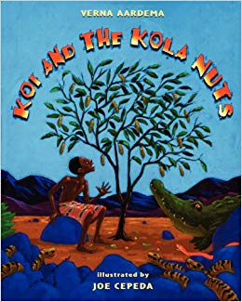
STEP 1
The initial stimulus is reading the story "Koi and the Kola Nuts" (Liberia's traditional fable)
This is the story of a boy who learns an important lesson about being generous and kind to others.
Koi does not inherit anything but the seeds of the kola tree from his father, the boy decides it is time to explore the world. He fills the bag with kola nuts and sets off on his adventure. Along the journey, he meets and helps a series of creatures to solve their problems by sharing his Kola nuts with them. When Koi finally arrives in the kingdom of King Fulikolli, the creatures repay him for his kindness helping him to win the hand of the king's daughter. This is a fascinating story that emphasizes the value of helping those in need.

Follow up questions - support with appropriate images to promote interaction and engagement.
1. Which animals did you meet with Koi after leaving the village? (Snake, ants, alligator)
2. How does it help them? (He is kind to them and gives them nuts)
3. What are the trials that Koi must overcome? (Break down the tree, collect the wheat, find the ring)
4. Who helps Koi in completing the trials? (The snake, the ants, the alligator)
5. Why do you think the animals helped Koi? (He had been kind and generous with them, so they are kind to him too)

Main Activity
STEP 2: EXPERIENCING EMPATHY
- Write on the board the following sentences:
Examples of positive sentences:
• You look sad, what happened to you?
• You are without a pencil case, can I lend you my pen?
• Do not worry, I'll help you fix the shelf.

Examples of negative sentences:
• You can not play because we have already started the game.
• Stop laughing, you bother me!
• You haven’t got a nice dress.
• Your shoes are old.
- Ask children to identify the differences between the positive and negative sentences. How do the positive and negative words make you feel?
- Teacher hammers a nail into a piece of wood and removes the nail to show the mark left behind as a visual illustration that negative, unkind words have the power to hurt.
- In pairs children think of an unkind or upsetting word for each letter of the alphabet. These are the negative words. Exchange lists with another pair but this time add in a column of alternative positive words for each letter of the alphabet.
- Provide images showing children from other countries. They could also be shown the flag of the country and listen to the national anthem. Choose these photographs carefully to illustrate a breadth of diversity and avoid promoting stereotypical views of poverty, gender, housing etc.
- Pupils draw themselves on a post it note and place it in the photograph on their table. Encourage the children to imagine they are in that new place. What can they see? What can they touch? What can they taste? What can they hear?
- They are meeting the child in the photograph. What would they like that child to do? What would they like that child to say to them?
- Turn the situation round - what if the child in the picture came to our school to visit you? How could you make them welcome? Write some kind phrases that could be said to welcome the children if they visited our school.

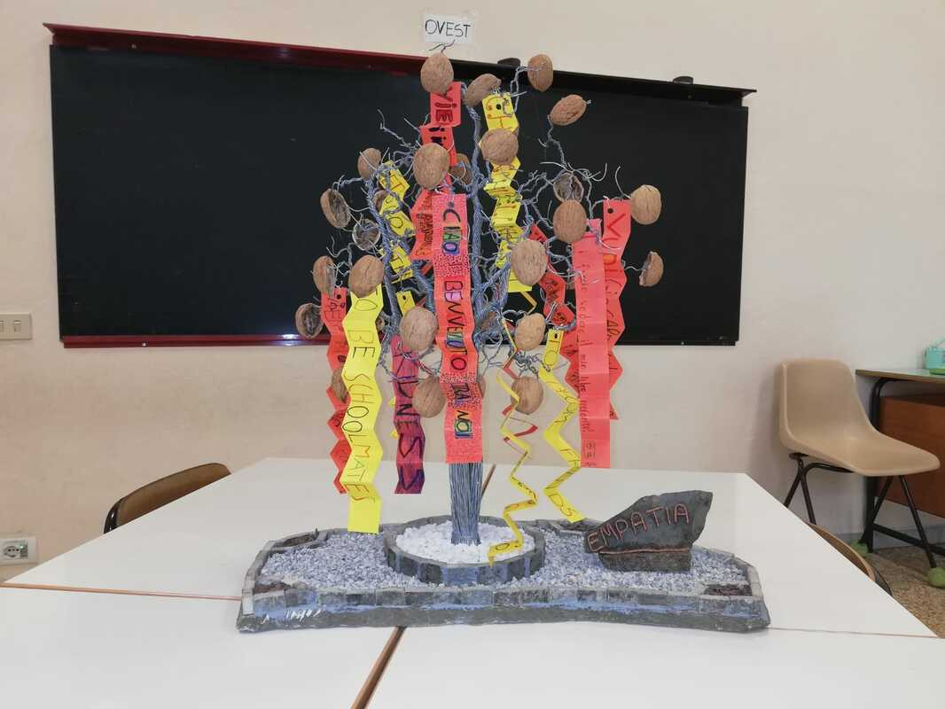
STEP 3: THE EMPATHY TREE
- Construct a class kola nut tree with sentences with positive, empathetic messages written by pupils in Italian and English on the leaves or on streamers.

STEP 4: ROLE PLAY
Give each group a scenario to improvise into a short role play.
Situation 1
You see that a new child at school is ignored by the other pupils. You decide to get close to him and start talking to him.
Roles: • New child • Group of students who ignore it • Kind child. Use kind words to help the newcomer.
Situation 2
There is a child in your class who seems very shy and who often plays alone during the breaktime. One day you decide to go and play with him and ask others if they want to do the same.
Roles: • Shy child • Group of students who want to play with him • Other children.
Situation 3
Your two best friends make fun of a child from another class who hasn’t got many friends. You do not like what your friends are doing.
Roles: • Two friends • Child of another class • Child who does not like others to make fun of someone.
Situation 4
There is a new child at school who comes from another country and does not know Italian well. Some children do not want to talk to him and make fun of him for his foreign accent. You changed school the year before and you know what it feels like.
Roles: • Foreign child • Child who wants to help him • Other children.
Situation 5
At school there is a child who sometimes beats the other children and therefore he is without friends. You would like to help him and ask your teacher’s help to find out how.
Roles: • Aggressive child • Child who wants to be his friend • Teacher

Plenary
Give each group opportunity to share their role play with the rest of the class. Can they identify the theme of the role play? How did the characters behave and how did they feel? Was the message powerful? Could it have been improved in any way?
After all groups have performed can the children identify any common themes across all the scenarios? Can they give examples of how kindness and interest in others has been demonstrated in the role plays?
Extension - Groups can turn their improvised role plays into short written play scripts to collect into a class book.
Role plays can be filmed or shared in an assembly to promote positive language and values across the school community.

What were the Outcomes?
The children developed a better understanding of the power of words to encourage or destroy - have a positive or negative impact.
Their vocabulary was increased and their use of language was more thoughtful and precise.
They were more able to express their own emotions and appreciate the feelings of others in different situations.
They were able to rehearse positive social interaction and explore ways to increase social and communication skills.

