Title of Lesson | Time Required | Age Range | Resources required
Migration Journeys – Who will you take on the journey? | 30 minutes | 10 - 13 | Prepared labels or post it notes - one per child

Lesson Objective | Knowledge and Understanding (Global Theme covered) | Global Skills covered | Global Values and Attitudes covered
Demonstrate the importance of interpreting body language correctly.  Understand the way in which the perceptions of others, particularly first impressions, influence interpersonal relationships. | Identity and diversity | Critical and creative thinking  Empathy | Sense of identity and self esteem  Value diversity

Introduction
The preconceptions that others have of us influences our conception of who we are and what we can be. In the case of racism, stereotypes determine not only intercultural coexistence but the identity of the immigrant. For example, in education and as Professor Jose Antonio Jordán of Barcelona University states, "the attitudes of teachers and expectations of school success that they have of students of foreign origin will be decisive for their academic careers."
The attitudes we have towards people we consider different can be very subtle and we may not be aware that we act with prejudice. However, this unconscious bias exists and clearly influences interpersonal relationships being sometimes a factor of exclusion.
This activity helps address the power of words to label people and how this influences social interactions. It can be used as an additional activity to the migratory journey project or with other activities to increase intercultural and self awareness.

Main Activity
Methodology:
Group.
Time: 1 session.
Material: As many white stickers as there are people in the group, markers.
Process.
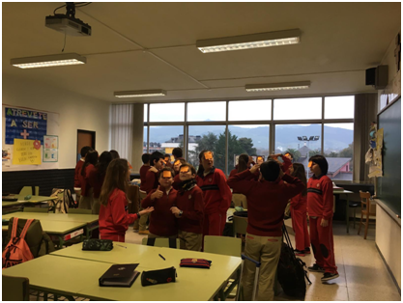
- A specific characteristic is written on each sticker, eg: liar, dirty, sympathetic, collaborative, lazy, tired, hardworking, responsible, sick, disobedient, obedient, educated, animated, quick, witty, moody, unfriendly, black, gypsy, smart, little, short, slow, boring, funny, older, brave, sincere, sad, happy ...
- The children make a circle facing outwards, so they are unable to make eye contact with each other
- The teacher puts a sticker on the forehead of each participant, without them knowing what is written
- They are informed that they will have to undertake a very long trip and that they should look for a person to accompany them.
Instructions for the group:
- Scatter around the room when I give the signal.
- You have approx. Ten minutes to choose your "ideal partner" for a trip.
- After ten minutes, all of you must be paired.
- You must sit together holding hands.
After the pairing:
- Which person have you chosen?
- Was she your friend?
- Did the label on your forehead influence your choice?
- Have you rejected any partner for the qualification of the label?
- On the contrary, have you deliberately chosen someone who had a negative characteristic? Why?

Plenary
Questions for reflection:
- How do we feel when people already have a preconceived idea of us?
- Why do we usually attribute certain characteristics to groups?
- Where do these ideas and influences come from?
- How does a person feel when they are confronted with prejudicial behaviour or discrimination?
- What shapes our body language, is it the same across all cultures?-
- How do you react to other people's responses to you?
- When you feel discriminated against to whom do you go?
What were the Outcomes?
The children developed a greater understanding of how labels can lead to prejudicial behaviour.
They became more aware of how our perceptions of other people are influenced.
They considered the dangers of stereotyping and how it can lead to misrepresentation and isolation.
The children became aware of the danger of relying on first impressions to make decisions or judgements.
They were helped to understand that identity has many aspects and that everyone has something to offer the wider community.

